HERO Padel-19 – APPROVED

More room to play. More space for nature.
Padel is finding its way into more people’s lives. Participation in Britain more than doubled in 2025, with 860,000 people taking to the courts. As enthusiasm grows, so does demand for places to play.
In Milton Keynes, we’ve helped Padel MK navigate biodiversity net gain (BNG) requirements for a development of seven new padel courts and supporting facilities, alongside the restoration of two existing all-weather playing pitches.
[Read the full story]
The scheme brings together investment in local sporting facilities and lasting gains for nature. Our part has been to help the team find a practical way to address its BNG requirements, supporting its plans to bring more opportunities for sport to the community.
Toby Phipps, Director, Padel MK, said:
“Padel is a sociable sport, and we’re excited to give more people the chance to get involved. We needed to understand how BNG would fit into our plans. Biofarm helped us work through the requirements and find a practical way forward, so we could focus on bringing the project to life. We’re proud that something designed to bring people together can also support lasting gains for nature.”
BNG is often discussed in the context of new homes. Projects like this show its wider reach, connecting the places where people work, play and spend time together with the restoration of the natural world around them.

Worth Abbey Community Day – Awaiting Sign Off
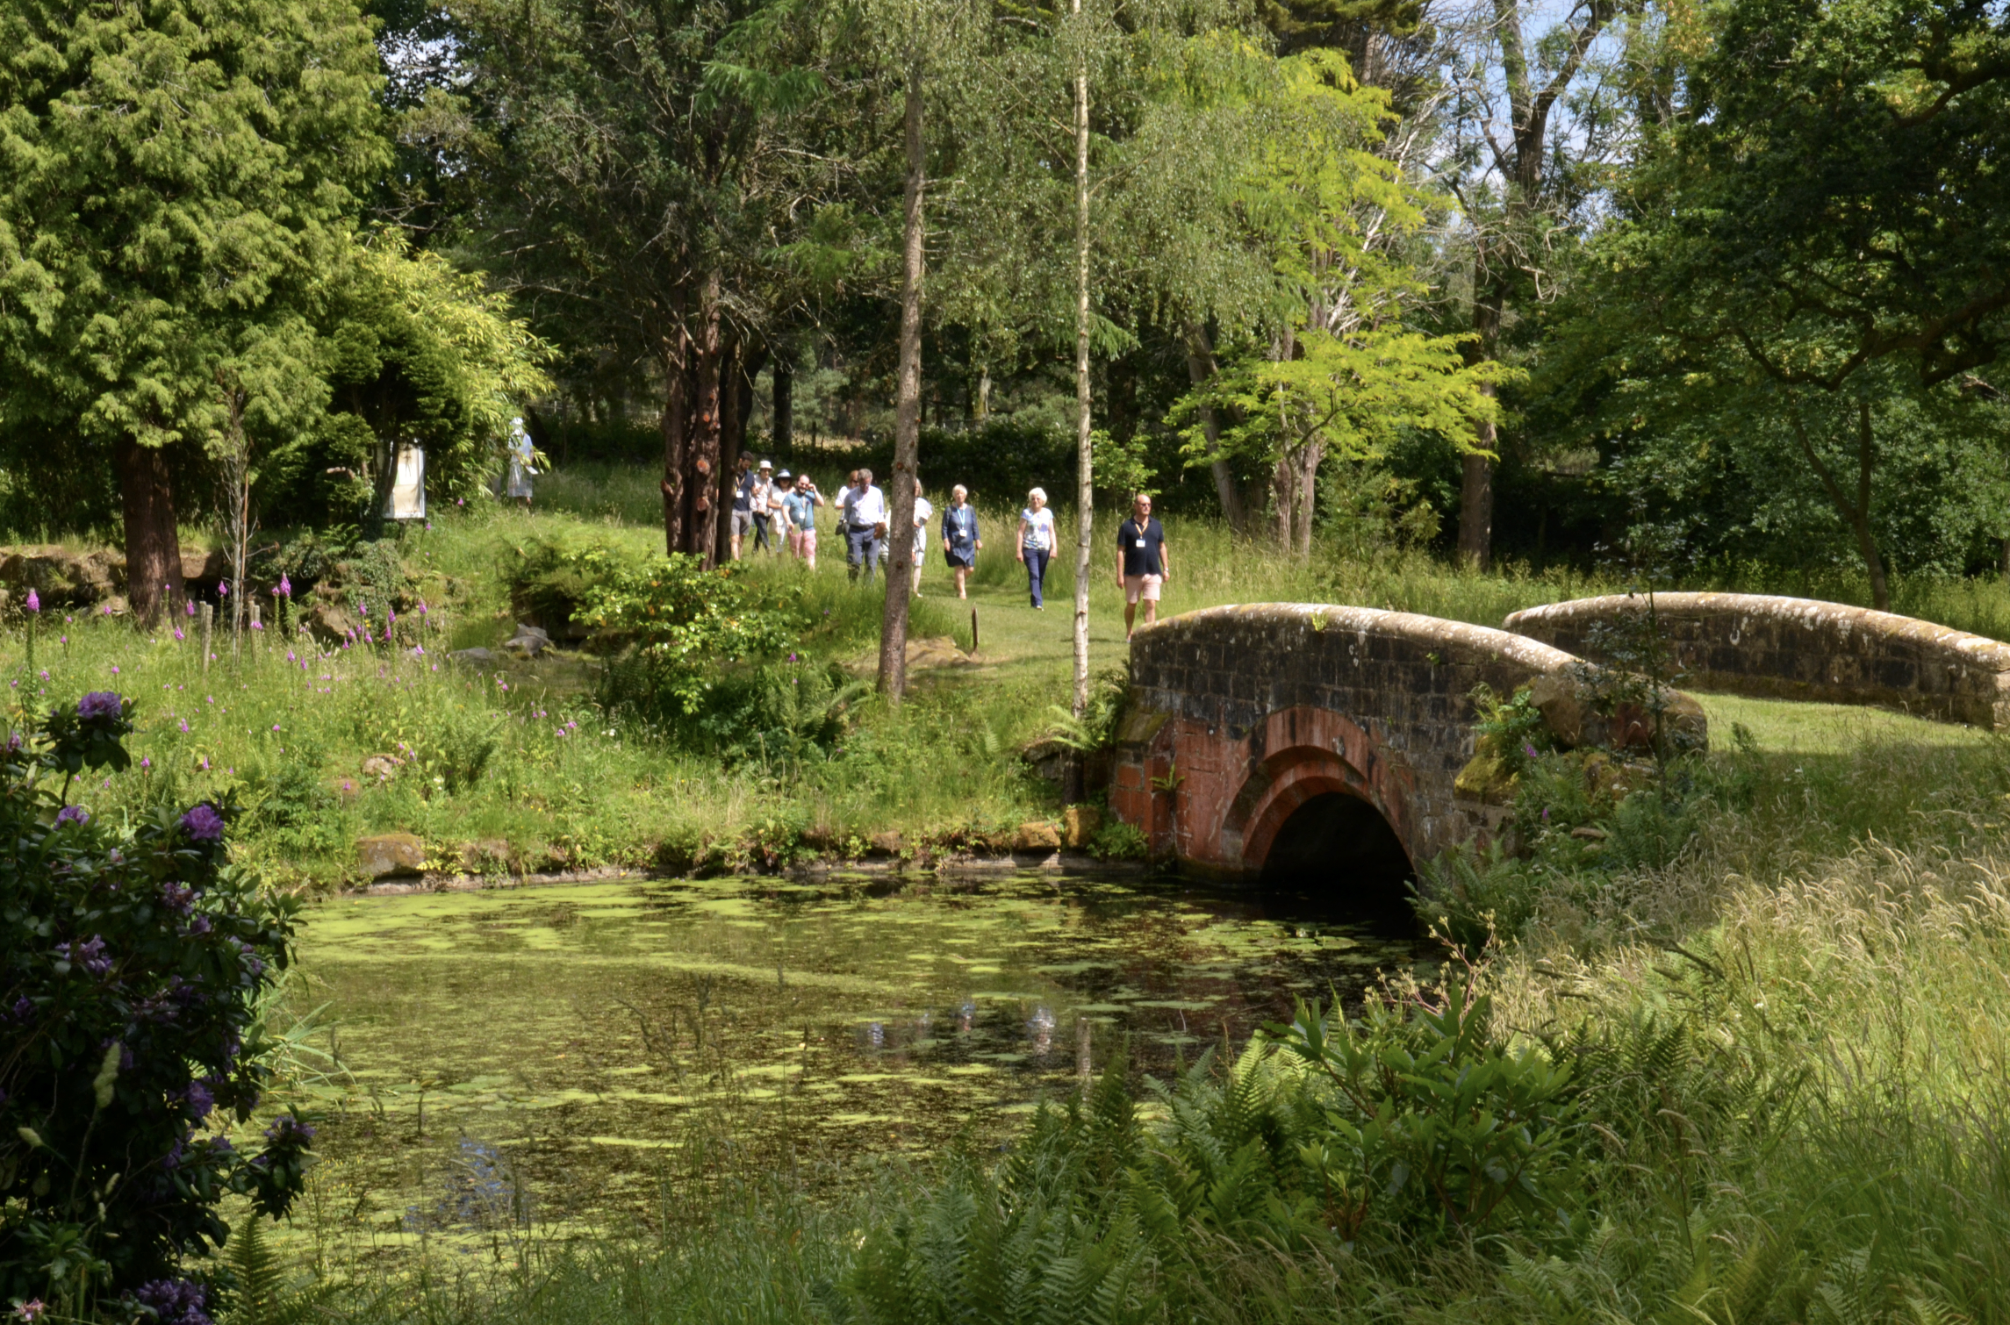
Growing our partnership with Worth Abbey
Last month, members of the Biofarm team joined the Benedictine monastic community at Worth Abbey in West Sussex for its Community Day, sharing more about our work together and the role Biodiversity Net Gain can play in the long-term future of the estate.
[Read the full story]
Growing our partnership with Worth Abbey
Set within 450 acres in the High Weald, Worth Abbey is a working monastery, school and community with a long tradition of stewardship. Its grassland, woodland and farmland are an important part of that legacy.
Our partnership builds on this commitment to the land. Across around 25 hectares of the estate, the Worth Abbey habitat bank will create and enhance lowland meadow, neutral grassland, mixed scrub and trees, generating 131 BNG units for development across Mid Sussex and the wider South East.
The restoration will also help reconnect habitats across the wider landscape, with Worth forming part of Weald to Waves, a nature recovery corridor stretching across Sussex.
But our work here goes beyond habitats and biodiversity units. We’re building a long-term relationship with the people who know and care deeply for this place.
Abbot Mark Barrett commented:

“Our partnership with Biofarm gives us an opportunity to build on our long tradition of caring for this land, restoring habitats for nature while supporting our wider vision for the estate and the community that shares it.”
Joining the Community Day gave us the opportunity to talk directly with the monastic community about what lies ahead, answer questions and hear their perspectives on the landscape we’ll be helping to restore.
Because when we commit to managing nature recovery for decades, we believe in investing in the relationships around it too.
Planning a development in Mid Sussex or the wider South East? BNG units at Worth Abbey are available to discuss now. Get in touch with our team to explore whether the habitat bank could be right for your scheme.

Badger Bank Farm Showcase – APPROVED
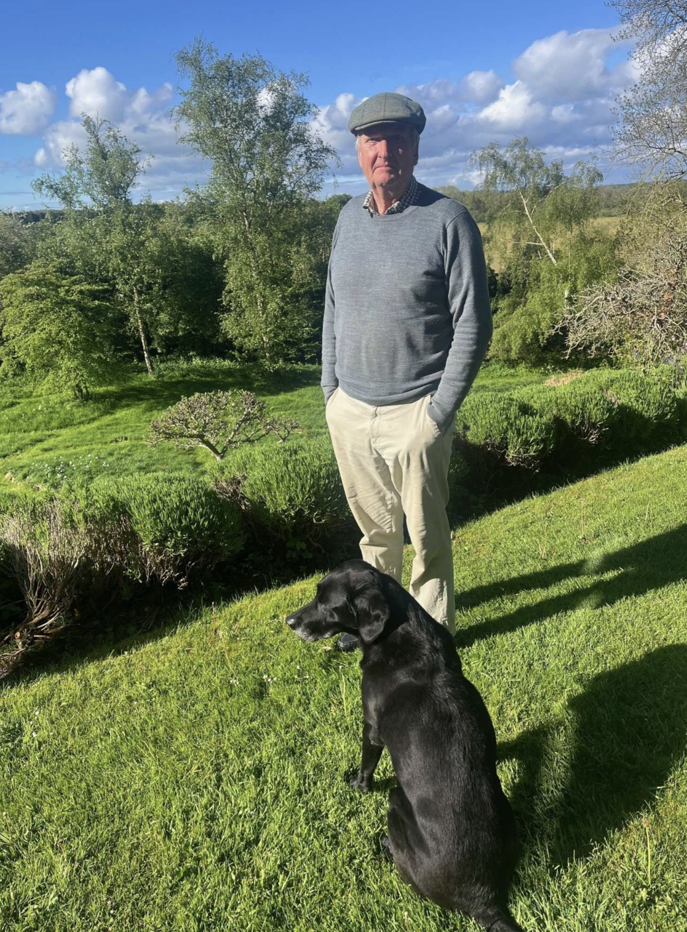
Image description/alt text: Badger Bank Farm landowner, Richard Graham, surrounded by grass and trees in North Yorkshire
Image caption: Richard Graham is partnering with Biofarm to create a thriving habitat bank at Badger Bank Farm, supporting local development and a lasting future for nature.
Local by nature | Badger Bank Farm, North Yorkshire
At Badger Bank Farm, we’re transforming 30 hectares of predominantly arable land into a thriving mix of grassland, scrub, trees and hedgerow. With 232 BNG units across the scheme, this registered habitat bank brings together a practical solution for developers and a lasting investment in North Yorkshire’s landscape.
Set beside ancient woodland and close to the River Ure corridor, Badger Bank will help nature thrive beyond its boundaries. Species rich grassland, native scrub and scattered trees will create more space for farmland birds, provide feeding routes for bats and help reduce nutrient ruoff into the river catchment.
For developers, that means access to grassland, scrub, individual tree and hedgerow units, backed by Biofarm’s long term management and monitoring. Funding is ring fenced for the full 33-year term, supporting the work needed to establish these habitats and care for them as they grow.
Richard Graham, landowner at Badger Bank, said:
“Working with Biofarm gives us the expertise and long-term support to make these plans a reality. We want to create more space for wildlife, connect the woodland around us and improve how the land holds and filters water. It’s about leaving the land in better shape for the future.”
Location: North Yorkshire
National Character Area: Southern Magnesian Limestone
BGS: BGS-060526001
Interested in Badger Bank? Contact the Biofarm team to discuss unit availability, habitat types, pricing and your project’s planning requirements.

Lesnewth Skiddy Activation - APPROVED
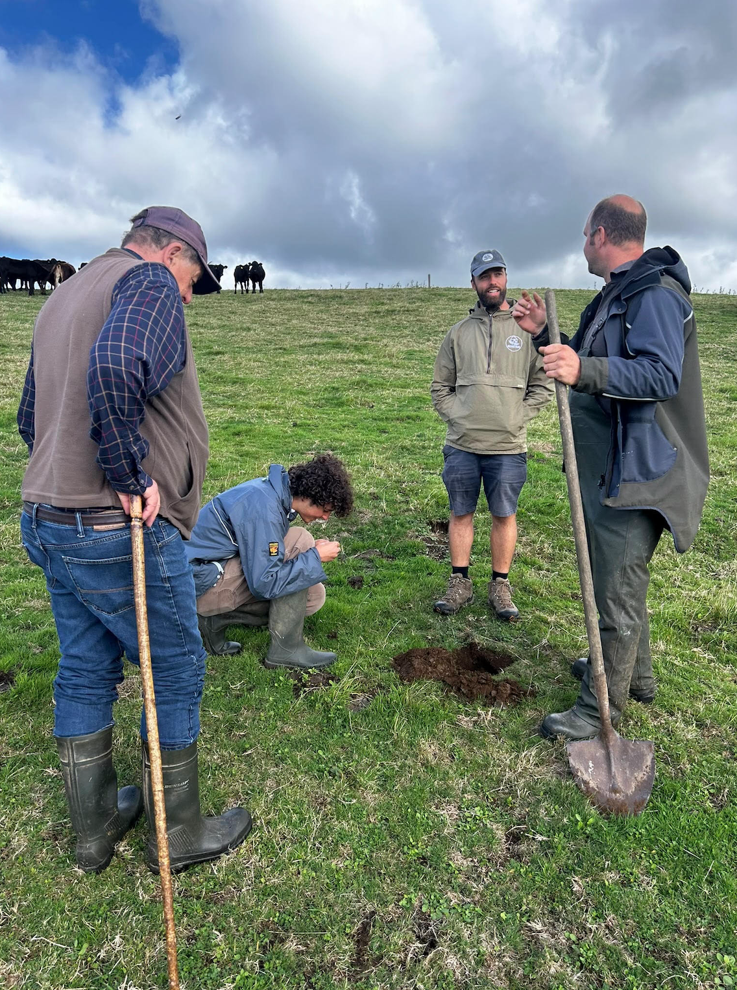
From the ground: the real work starts at Lesnewth
At Lesnewth, our ecology and land teams met with the landowner, grazier and Cornwall Wildflower CIC to plan the habitat bank’s first activation: establishing 3ha of wildflower meadow.
[Read the full details]
Standing in the field, the team worked through the practical details: how to prepare the ground, when to sow and, importantly, what should go into the seed mix.
Rather than using a standard wildflower mix, the seed is being carefully selected to suit the local conditions and character of this part of North Cornwall. It’s about creating the right meadow, in the right place.
Over the coming weeks, the field will be prepared and sown, before the cattle stay off through the winter to give the meadow time to establish.
This is the first activation at Lesnewth and the beginning of the habitat restoration planned across the wider habitat bank. Over time, wildflower grassland will sit alongside enhanced woodland, scrub and Cornish hedgerows, creating stronger connections for nature across the landscape.
For us, this is what long term BNG delivery looks like on the ground: bringing together ecological expertise and the people who know the land to make the right decisions for the landscape.
Looking for BNG units in Cornwall? Talk to us.

Westbourne Homes – APPROVED
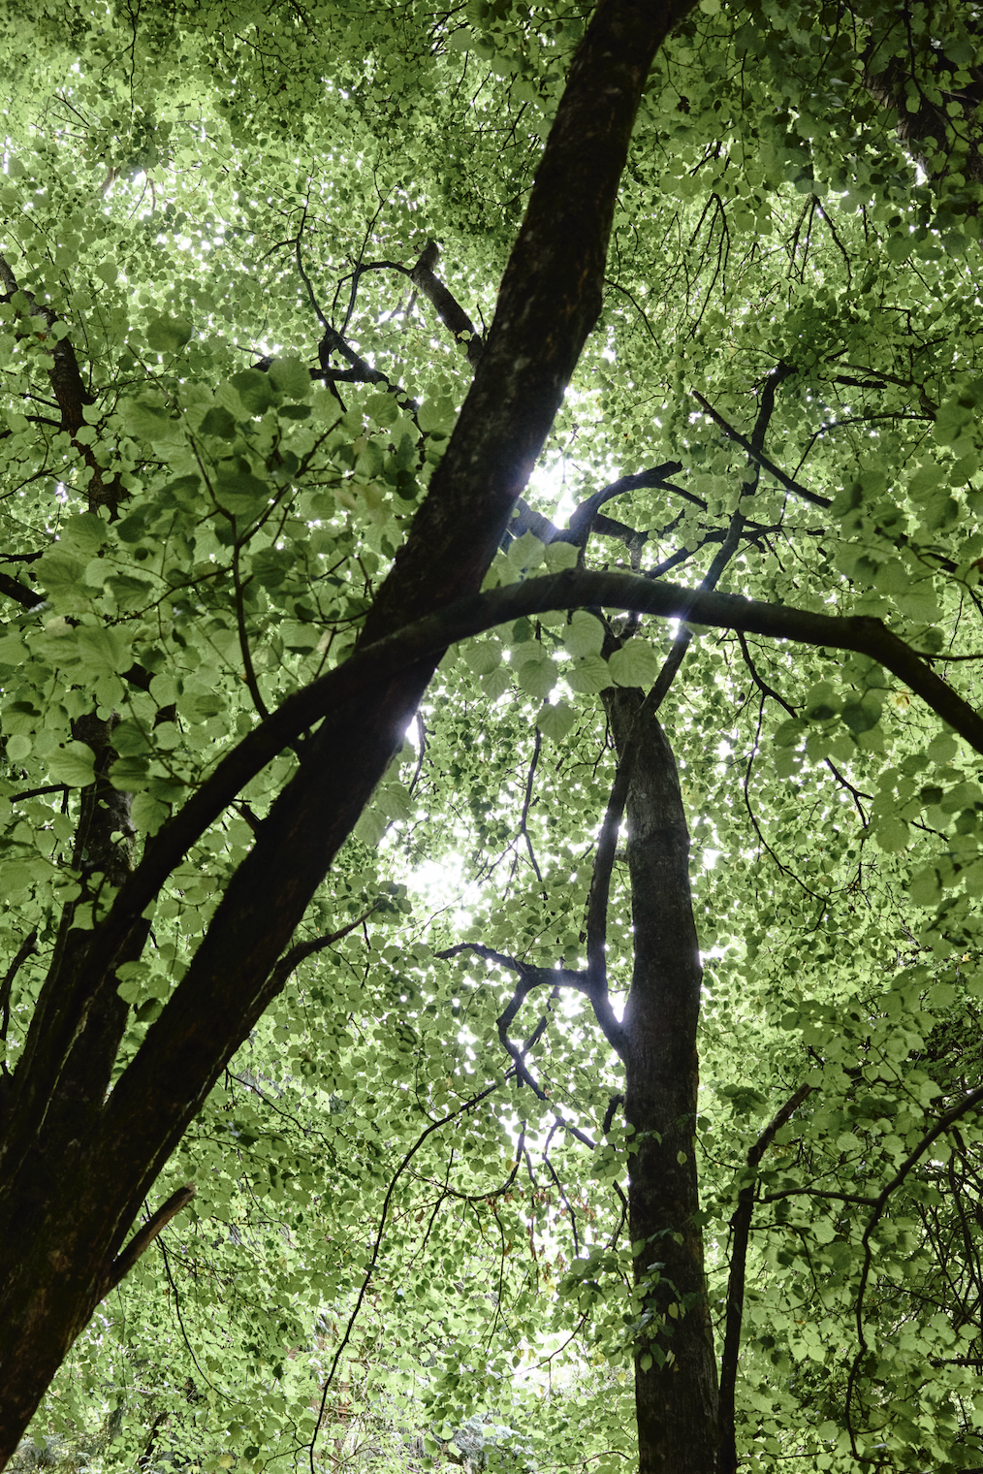
Westbourne Homes: When 10% isn’t the whole BNG story
Westbourne Homes is developing Ladds Garden Centre in Wokingham into 19 new homes, with most of its biodiversity net gain delivered on site.
Overall, the scheme was already above the required 10%. But replacing some of the site’s established habitats needed a more strategic approach.
[Read the full story]
While most of the BNG could be delivered on site, some habitats were better suited to off-site delivery. Biofarm supplied the additional units through its Sleight Farm habitat bank.
That’s where off-site BNG can really work. Habitats that are difficult to replace within a development can become part of a bigger, connected plan for nature, without adding more long-term management for future residents.
BNG isn’t just about reaching 10%. It’s about finding the right place to deliver it.
Charlie Simpon, Managing Director of Westbourne Homes, said:
“We wanted a BNG solution that worked for the development and for the people who will eventually call it home. Biofarm helped us find that balance, while making sure we deliver for nature too.”
Could off-site BNG work better for your development? Talk to us.

Policy changes – APPROVED
(DESIGN NOTE: PRESENT LIKE A FACT FILE)
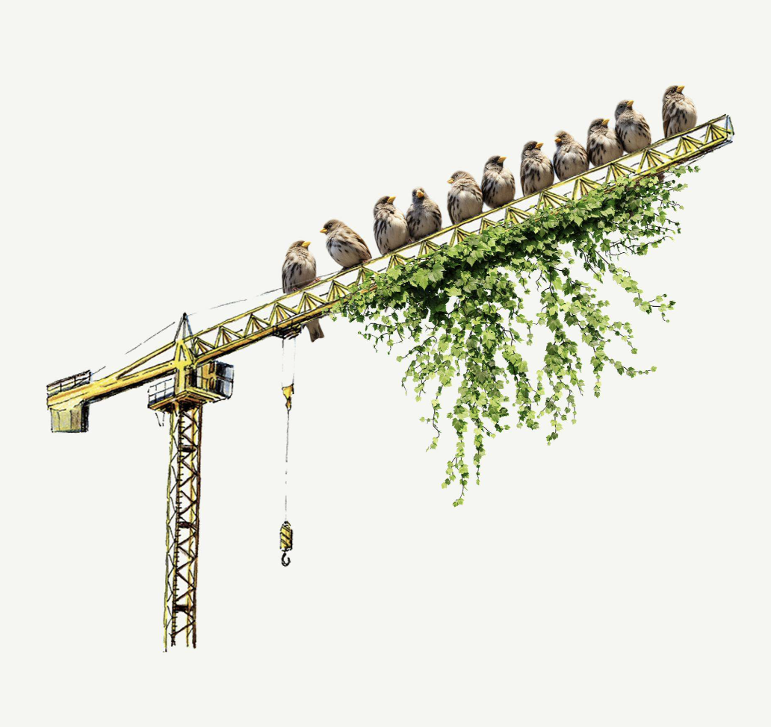
BNG fact file: what changed and what stayed
BNG rules changed over the summer. The system is now more proportionate, but the 10% requirement and market for offsite units remain firmly in place.
The 10% requirement still stands
- Qualifying developments in England must deliver at least 10% BNG.
- The main exemptions include home extensions and loft conversions, work permitted without a full planning application, sites of 0.2 hectares or less and temporary developments of five years or less.
- Priority habitat protections still apply.
- Self-build and custom-build developments are no longer automatically exempt.
Offsite BNG is more accessible
- Onsite habitat creation, onsite enhancement and registered offsite gains now have equal priority.
- This applies to non-major developments (fewer than 10 homes or smaller commercial schemes below the major development thresholds).
- Developers can choose the most practical route from the outset.
- This supports continued demand for high integrity units and long-term opportunities for landowners.
- Statutory credits remain the last resort.
Major infrastructure is next
- From 2 November 2026, BNG will become mandatory for Nationally Significant Infrastructure Project applications.
- This includes major energy, transport and water schemes.
More flexibility for development. More opportunity for nature.
Not sure whether your scheme requires BNG?
Get in touch. We’ll help you understand what applies and find the right route forward.

------
ARCHIVE
HERO: Cassidy and Ashton Partnership – Awaiting Client Approval - Pulled
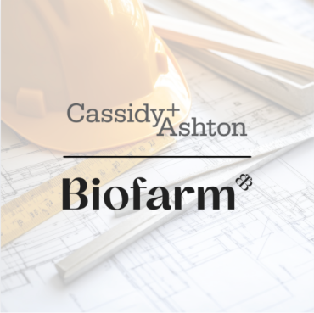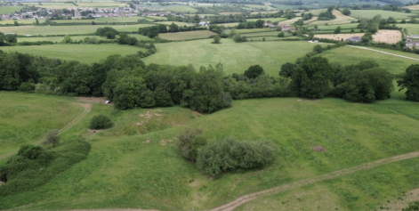
(Internal note: Sleight Farm, Drone Day 26)
Caption: “Part of the project’s Biodiversity Net Gain requirement is being delivered through long term habitat bank creation and management at a Biofarm registered habitat bank.”
A smarter BNG solution supporting major investment
A bespoke BNG solution helped keep a major programme of renovation and construction moving at a significant aviation technology site in Rochester, while delivering the right outcome for nature.
[Read the full article]
The site is undergoing a £220 million transformation, including extensive renovation and the construction of a new 32,000 square metre advanced technology factory.
It is home to a 1,600 strong workforce and develops advanced technologies for civil and military aircraft. It also provides year-round repairs for commercial airliners and is an important source of skilled employment in Medway. The investment is expected to create a further 300 jobs.
To support the wider programme, the project team needed to bring additional land into operational use. But the land included a nationally important open mosaic habitat, creating a complex biodiversity challenge.
Working alongside town planning and environmental consultancy Cassidy & Ashton, Biofarm designed an integrated solution that enabled the client to deliver its BNG requirement both onsite and offsite.
Planned habitat delivery on the development site would meet part of the requirement. Biofarm brought this together with the right mix of offsite biodiversity units to meet the remaining need, securing long term habitat creation and management through a registered habitat bank.
By looking at the project as a whole, the solution significantly reduced the number of offsite units the client needed to purchase and, in turn, the overall cost of delivering BNG.
The result worked for the client and for nature. It provided a clear route through the biodiversity requirements, helped the wider programme progress and directed long term investment into habitat creation where it could deliver the greatest benefit.
Alban Cassidy, Director at Cassidy & Ashton, said:
“This was a complex project with important operational, commercial and ecological considerations. Biofarm took the time to understand the project as a whole and designed a solution that brought the onsite and offsite elements together. It reduced the client’s offsite BNG requirement and costs, while providing a practical route forward for a major programme of investment.”
[Contact us]

